Papers Format for “Replaying Japan”

Author Name 1
Ritsumeikan University, example@rcgs.jp

Author Name 2
Ritsumeikan University, example@rcgs.jp

Abstract
All papers must include an abstract. Japanese manuscripts should also have an English title and abstract. The Abstract must be 10-point Times New Roman. It should be no more than 300 words in length.

Heading 1
Para Normal must be 10-point Times New Roman.

Heading 2
Submissions need to be original works that have not been published elsewhere. In certain cases we will accept submissions of translations of papers important to the field.
English paper should be no more than 7,000 words in length (references are not counted).

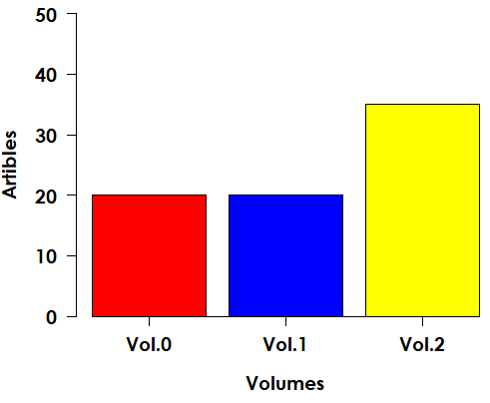
Figure 1. Number of articles

For the bibliographic format of references, the manuscript should follow the formatting rules of the Chicago Manual of Style (17th ed., Notes/bibliography style, also known as "Humanities” style).

Overall Format Specifications
All papers must use the following layout:

- ISO A4 (210 x 297 cm) paper size
- Portrait Orientation
- Two-column format for the body of the document
- Top margin: 2.8 cm
- Bottom margin: 2.2 cm
- Left and right margins: 1.8 cm
- Spacing between columns: 0.8 cm
- Indents - all paragraphs - 0.63 cm
- Header and Footers 0.5 inches

Table 1. Fonts and Size
Tag | Font | Size
Title | Arial | 14 pt, Bold
Author | Times New Roman | 11 pt
Affiliation | Times New Roman | 10 pt
Heading Abstract | Arial | 11 pt, Bold
Abstract | Times New Roman | 10 pt
Heading 1 | Arial | 11 pt, Bold
Heading 2 | Arial | 10 pt, Bold
Para Normal | Times New Roman | 10 pt
Footnote | Times New Roman | 8 pt

References
Hutchinson, Rachael. 2011. Nagai Kafu's Occidentalism: Defining the Japanese Self. Albany: State University of New York Press.
KALINSKE, Thomas J. “The Experts Are Always Wrong.” Replaying Japan, 2018, 77–84.
﻿Newman, James. “Slower, Squashed and Six Months Late: Japanese Videogames in the UK, 1991-2019.” Replaying Japan 1 (2019): 5–28.

Footnote must be 8-opint Times New Roman.

